**Web site edits**

Upper left corner of each page should link to “DeVault Lab Home”

Add main section (upper right headings) for “Reprints”

Since I sent you that list I had another paper accepted: Greggor, A. L., O. Berger-Tal, R. R. Swaisgood, S. J. Cooke, T. L. DeVault, E. Fernández-Juricic, A. Gienapp, S. Hall, C. Hostetter, M. A. Owen, S. Rankin, K. A. Ruppert, J. P. Swaddle, and D. T. Blumstein. 2021. Using change models to envision better applications of animal behavior research in conservation management and beyond. Frontiers in Conservation Science: In Press.

Notice wording of some headings has changed somewhat

What We Do

The DeVault Wildlife Lab is a research group at the University of Georgia’s Savannah River Ecology Laboratory (SREL) [link]. We apply behavioral and ecological concepts to problems arising from interactions between wildlife and people, especially with regard to understanding and mitigating animal-vehicle collisions and the conservation and ecology of vertebrate scavengers. As such, our research interests span basic ecology and applied conservation and management. Although much of our work involves birds, our research is question-driven rather than strictly taxonomically-focused. We are highly collaborative and interdisciplinary. Welcome to our site and feel free to browse these pages and let us know if you have questions or comments.

Where We Work

SREL, a research unit of the University of Georgia, pursues basic and applied research at multiple levels of ecological organization, from atoms to ecosystems. SREL is located near Aiken, SC, on the Savannah River Site, a Department of Energy facility, and the first national environmental research park. The lab’s research extends beyond the site to regional and global projects. To date, the lab has produced more than 3,000 peer-reviewed publications. [give links where appropriate in this section]

Use this logo: 

People

Travis DeVault

Travis DeVault is the Associate Director for Research and Senior Research Scientist at the University of Georgia’s Savannah River Ecology Laboratory [link]. He also has a courtesy faculty appointment in the Warnell School of Forestry & Natural Resources [link] where he advices graduate students. He earned bachelor’s and master’s degrees in ecology and systematics from the Department of Biology at Indiana State University [link] and a PhD in wildlife ecology from the Department of Forestry and Natural Resources at Purdue University [link]. Travis is a wildlife ecologist and conservation biologist; his research focuses on understanding and preventing animal-vehicle collisions and other human-wildlife conflicts. He also maintains a long term research interest in the ecology of vultures and other vertebrate scavengers. Outside of work, Travis is a jack of all trades and master of none. He’s an eclectic sort who enjoys fishing, hunting, kayaking and canoeing, hiking with his family, wrestling with his dogs, playing basketball, obsessing over Chicago Cubs baseball and Indianapolis Colts football, blues guitar, tinkering in his woodshop, and playing video games while consuming bourbon and scotch. Actually, he is pretty good at that last one.

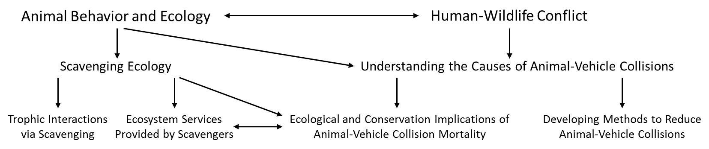

Jon Skaggs

Mary Chapman

Shayna Munoz

Carson Pakula

Shane Guenin

Current Research [add photos for all these sections where appropriate]

Understanding and Preventing Animal-Vehicle Collisions

[Brief introduction to this overall research area] Animal-vehicle collisions (AVCs) are ubiquitous across the developed world. AVCs cause billions of animal deaths each year and pose substantial safety threats and economic costs to people. Research on AVCs in the DeVault Lab is focused on learning why AVCs occur by investigating what goes wrong from the animal’s perspective when they are struck by vehicles. DeVault Lab members then apply that knowledge to the development of mitigation measures designed to reduce collisions.

Project Blurb on Carson’s study (1 or 2 paragraphs—Carson should draft and I’ll edit)

Project Blurb on Shane’s study (same)

Scavenging Ecology

[Brief introduction to this overall research area] Scavenging is much more than a curiosity of animal behavior; carrion consumption is widespread and common among terrestrial vertebrates and can have substantial impacts on communities and ecosystems. Our work in this area has branched into several lines of inquiry, the most recent of which intersect with our interest in the causes and consequences of AVCs. With our collaborators, we recently investigated the magnitude of animal mortality caused by AVCs, how carcasses produced from automobile strikes influence animal communities through scavenging, and the role vultures play in providing ecosystem services by consuming biomass produced from AVCs.

Avian Ecotoxicology

Brief introduction to this overall research area (Jon draft this and I’ll edit)

Project Blurb on SHEP study (Jon draft and I’ll edit)

Project Blurb on H02 wetlands study (Mary draft and I’ll edit)

Collaborators

Did I already give you all these? Let’s link to each of them if we can.

Opportunities

Please add this main section. For right now, it should say “none currently available”

Contact

Dr. Travis DeVault

University of Georgia, Savannah River Ecology Laboratory

Office: (803) 725-5679

Regular Mail: PO Drawer E, Aiken, SC 29802

Courier: SREL, SRS Bldg 737A, Aiken, SC 29808

E-mail: Mask this somehow?

Prospective students

Please understand that we are a small research group by design, given that most of Dr. DeVault’s time is occupied by administrative duties at SREL. When we have openings they will be advertised on the Opportunities page. Even so, feel free to contact Dr. DeVault [link to email] or any other lab member by email if you are interested in our research program and might want to join our team.